**Project One: Diagnostic Center Bill Management System**

This web application will manage billing activities for a small diagnostic center. Generally, small diagnostic offers several types of tests like *Complete blood count, Lipid profile, Urine C/S-200, X-Ray LS Spine, USG Lower abdomen* etc. Since bill processing for these types of tests requires paper work and is very error prone, we are offering this application to process it automatically from their side. Following are the stories (with score) for the mentioned application.

|  |  |  |
| --- | --- | --- |
| **SL #** | **Story Name** | **Score** |
| 1 | Test Type Setup | 3 |
| 2 | Test Setup | 3 |
| 3 | Test Request Entry | 8 |
| 4 | Payment | 4 |
| 5 | Test Wise Report | 4 |
| 6 | Type Wise Report | 4 |
| 7 | Unpaid Bill Report | 4 |
| **Total** | | **30** |

1. **Test Type Setup**

User will enter some basic tests’ type (*like Blood, Urine, ECG, X-Ray*) using this UI. Type name will be unique. Type list will be ordered by Type Name.

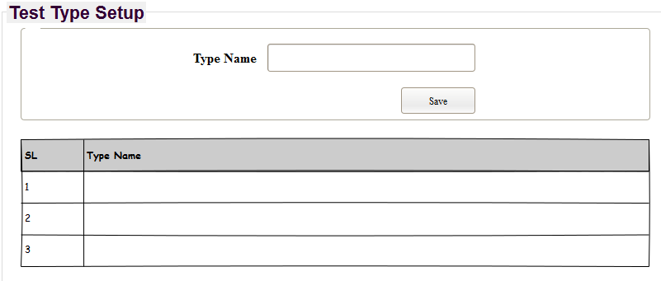

1. **Test Setup**

User will enter some basic tests information (*like whole abdomen, pregnancy profile, Urine C/S-200, X-Ray LS Spine*) using this UI. Test name will be unique. Test list be ordered by Test name.

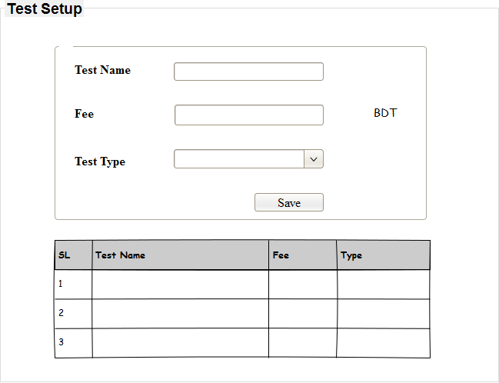

1. **Test Request Entry**

When a parient comes for some tests, user of the diagnostics will enter all tests information for this patient. When ‘Add’ button will be clicked, entered information will be displayed in grid. Finally, when user will click ‘Save’, all information will be saved in database and a PDF will be opened which contain unique bill number and print date.

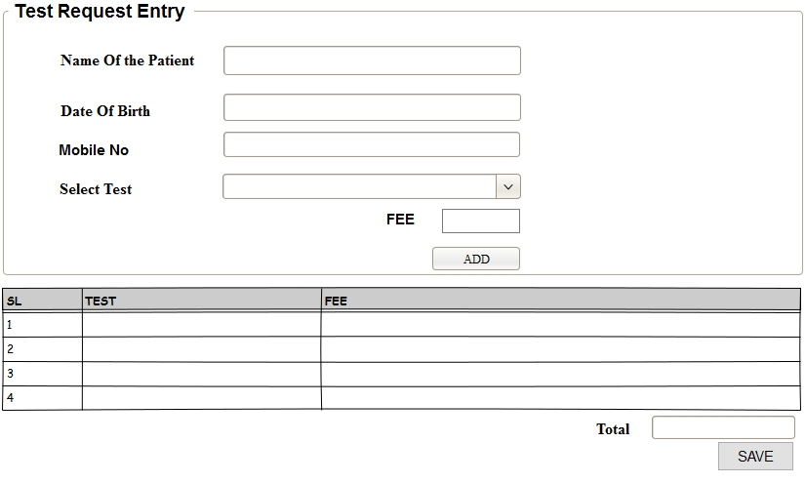

1. **Payment**

User of this UI will use it when patient comes to pay for the bill. User will enter *Bill No* and click *Search* button, *Total amount* and *due date* against this bill no will be diplayed. After that user will take amount from patient and click *Pay* button to update bill payment status.

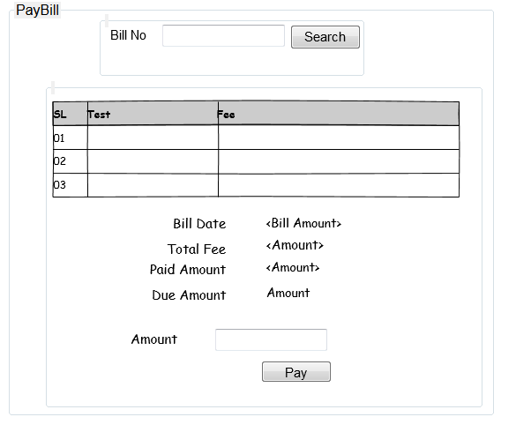

1. **Test wise report**

User will select *from* and *to date* and click *show* button, *test name, total number of tests* and *total amount* will be displayed. If any test has no test request for selected dates between, these will also be displayed with their number of test and total amount will be zero.

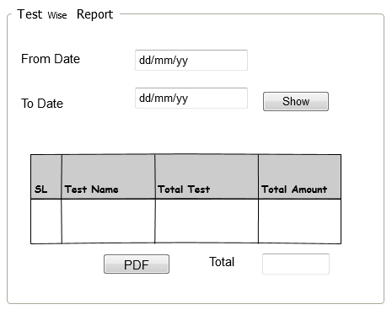

1. **Type wise report**

User will select *from* and *to date* and click *Show* button, *type name, total number of tests and total amount* will be displayed. If any *type* has no requested test selected date between, these will also be displayed and their total number of test and amount will be zero.

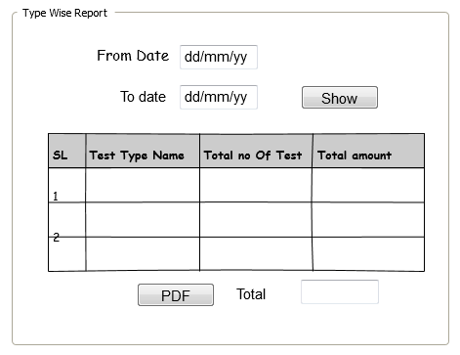

1. **Unpaid bill report**

All unpaid bill information will be displayed as following format.

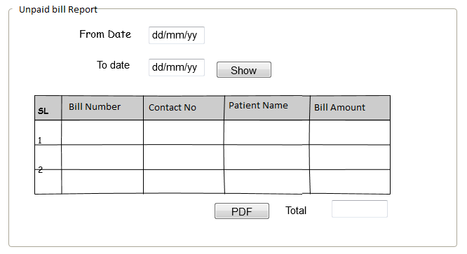

<-- END -->